**Combining terms:**

* steel columns - finds items containing both steel and columns (system assumes an **AND** between words)
* earthquake **OR** seismic – finds items containing any of the words: earthquake, seismic
* steel **NEAR**/6 column – finds items where the words steel and column are within 6 words of each other

**Compendex – database guide**

**Developing your search strategy (1):**

* Identify your key concepts (search terms)
* For each key concept think of alternatives (e.g. synonyms, related terms, broader/narrow terms)
* Combine terms using Boolean logic (**AND, OR**)

**USE GUIDE FOR:**

**Compendex**

**Inspec**

**Engineering Village**

**Example search topic: finite element analysis of behaviour of steel columns in earthquakes**

Key concepts: **finite element**, **earthquakes**, **steel columns**

This search finds items which contain: the phrase **finite element** or one of the acronyms **FEA**, **FEM**, *PLUS* (AND) any word beginning with **earthquake** (e.g. **earthquake**, **earthquakes**) or the word **seismic**, *PLUS* (AND) both the word **steel** and any word beginning **column** (e.g. **column**, **columns**)

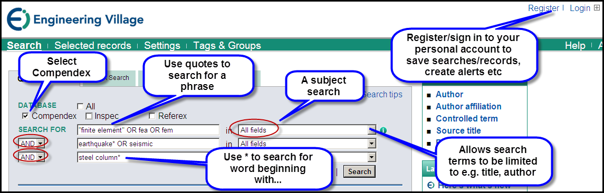

**Refining your search (some options):**

* Add/omit search terms to widen/narrow search
* Limit some search terms to title or index terms field
* Consider using: phrase searching, field searching (e.g. limit to title), truncation operator (*), proximity operator (NEAR/n)

**Developing your search strategy (2):**

* Review results – scan item titles, read summaries/abstracts to determine relevance/worth reading full text
* Refine search if necessary

